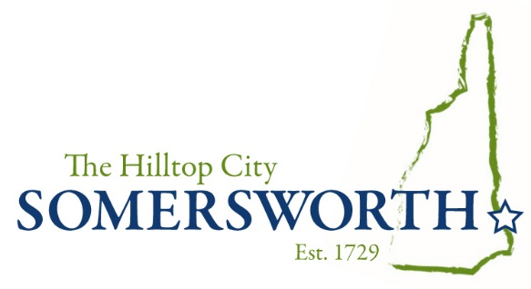

January, 2022
Somersworth Business Visitation Program
Survey

Contact
Robin A. Comstock
Economic Development Manager
City of Somersworth
One Government way
Somersworth, New Hampshire
rcomstock@somersworth.com
603-692-9516

www.somersworth.com

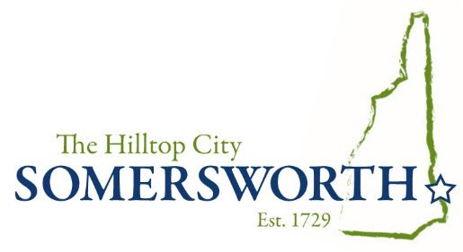

2022

Dear Somersworth Business,

If we don’t already know one another, I would like to introduce myself to you. I am the Economic Development Manager for the City of Somersworth. My position has been created to provide you and your business, support and assistance, when and where you may need it, while acting as your liaison to City Hall too. Therefore, it is important that I understand your needs and interests in regards to operating your company in Somersworth.

To accomplish these lofty goals, I continue to talk with as many Somersworth businesses as possible. Especially now, as life slowly becomes the new normal as a result of adjusting to the Covid pandemic, it’s important that we stay connected. Knowing your business priorities, concerns and successes too - will help me support you in ways that I hope will be positive and meaningful.

For many reasons, the annual Business Visitation Survey is more important now than ever before. It is a tool for you to convey your experience as a Somersworth business, and to let me know where your business may need support and assistance. Please email or mail your responses to me, and add any other thoughts you may have in “Open Comments”. Or, if you’re not interested in the survey, but - have thoughts to share, simply send me an email with, ideas or questions you may have.

Thank you for spending time to complete the annual Business Visitation Program Survey.

Sincerely,
Robin
Robin A. Comstock
Economic Development Manager
City of Somersworth
rcomstock@somersworth.com
Contact Information

Date
Business name
Business Address

City
State
Zip Code
Phone
Email

Contact name
Contact title
Contact phone
Contact email

Owner’s name
Owner’s Phone
Owner’s email

The History - Yesterday

- What year was the business established?
- Was your business first established locally?
- Was your business established as a family business?
- If so, how many generations?
- What was the primary service/product?
- Why did your business originally choose Somersworth?
- Open Comments

The Present - Today

- Is the business locally owned?
- If not, where are your corporate headquarters?
- What is your current primary product/service?
- How many full-time employees?
- How many part-time employees?
- Where do your employees live?
- What is the average employee’s education?
- What are your needs & interests for your workforce?
- What community resources are critical to the success of your business?
- What is your greatest current challenge?
- What is your greatest current threat?
- What is your greatest current success?
- What do you consider your current most important contribution to community?
- What is your greatest need from community today?
- Open Comments:

The Future - Tomorrow

- Will you be producing the same product & service in the future?
- Will you be delivering your product & service in the same way in the future?
- Will lessons and experiences from the pandemic stay with you into the future?
- Will your employee count change?
- What is your single greatest need from the workforce for your future?
- Will your current location still serve you in the future?
- What are the greatest advantages of your current location?
- What are the greatest disadvantages of your current location?
- Are you considering a (post covid) new model - downsizing or growing?
- Will you make changes to your business plan?
- What will be the major community factors affecting your business?
- Do you conduct business with other Somersworth businesses?
- Will you be in Somersworth in the future?
- Open Comments:

The City Relationship – Your Home Community
- If you could wave a magic wand for Somersworth, what would happen?
- In terms of workforce readiness - how do you rate the Somersworth Schools?
- How do you score the City infrastructure?
- What are the three things the City could do better to support your business?
- What issue that affects your business, needs the attention of the City?
- What do we need to understand, and what do we need to do differently?
- What hasn’t been asked that should be?
- Open Comments:

Covid -19 Pandemic

- How has Covid changed your business model?
- Will you continue to deliver your product/service in new ways?
- What are your biggest concerns relevant to the pandemic?
- Do you have new business issues that are a direct result of the pandemic?
- Are changes you made to your business during Covid sustainable?
- Do you need assistance or support that you aren’t getting, but want?
- What is your most profound lesson “take-away” from the pandemic?
- Open Comments:

If you prefer to express your thoughts in a conversation or as a personal email rather than completing this survey, please send me your email address or phone number, so that I am able to contact you

Robin A. Comstock
Economic Development Manager
City of Somersworth
One Government way
Somersworth, New Hampshire
rcomstock@somersworth.com
603-692-9516

